**2: Kubernetes vs AWS EKS Architecture**

**EKS kubernetes architecture**

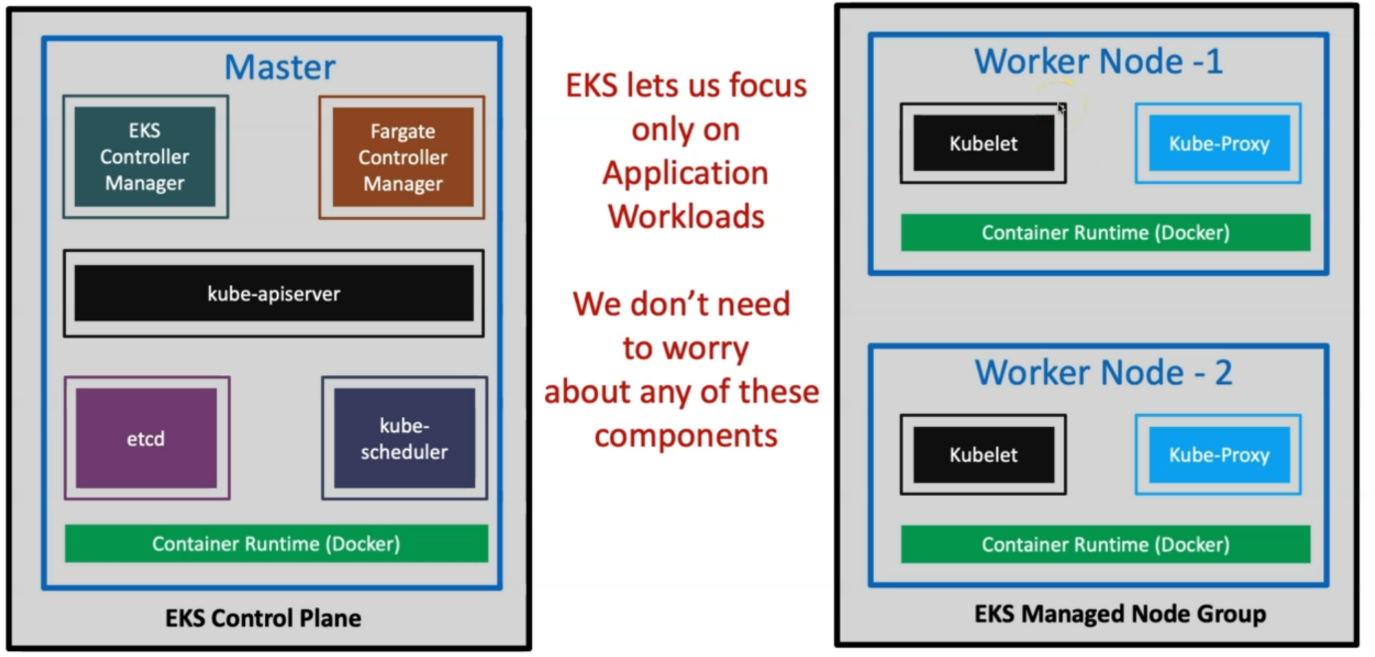

--- this is the architecture of EKS kubernetes architecture.

--- **note** – whatever component’s present inside of that blue box is not our responsible, everything is managed by aws. EKS lets us focus only on application workloads, we don’t need to worry about any of these components.

--- our focus will be on how to design the application and deploy into kubernetes cluster.

--- **note** – once we created the cluster for our application then our job is done. The end-to-end maintenance of all these components responsibility is aws.